**TASK-05**

Time Calculator

**EXPLANATION:**

The program asks the user to enter any number of seconds and If the number of seconds entered by the user is greater than or equals to 60, the program displays the number of minutes in that many seconds and If the number of seconds entered by the user is greater than or equals to 3600, the program displays the number of hours in that many seconds and If the number of seconds entered by the user is greater than or equals to 86400, the program displays the number of days in that many seconds.

**INPUT:**

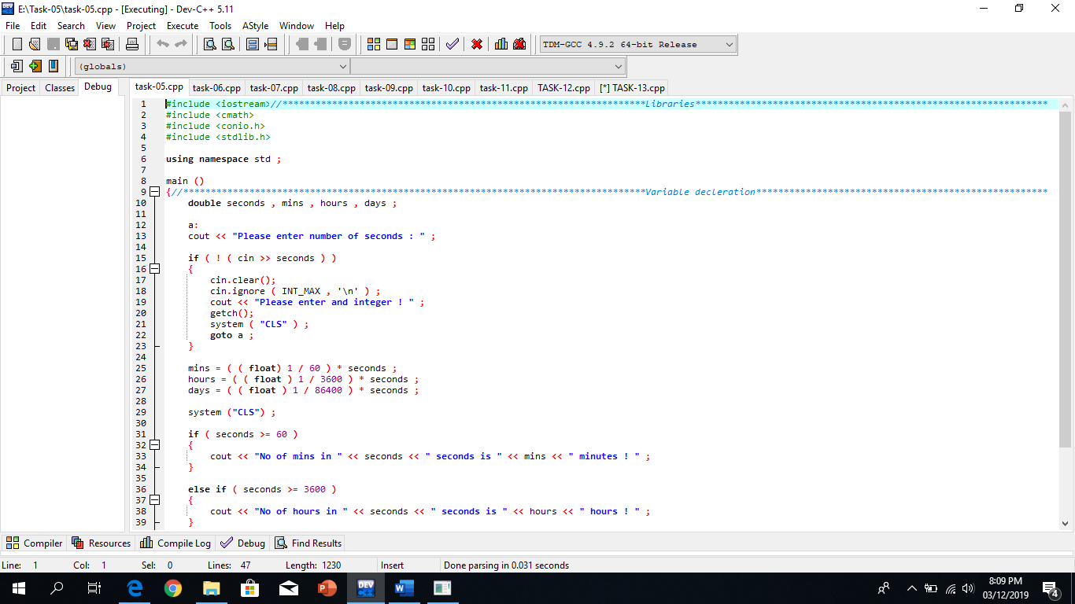

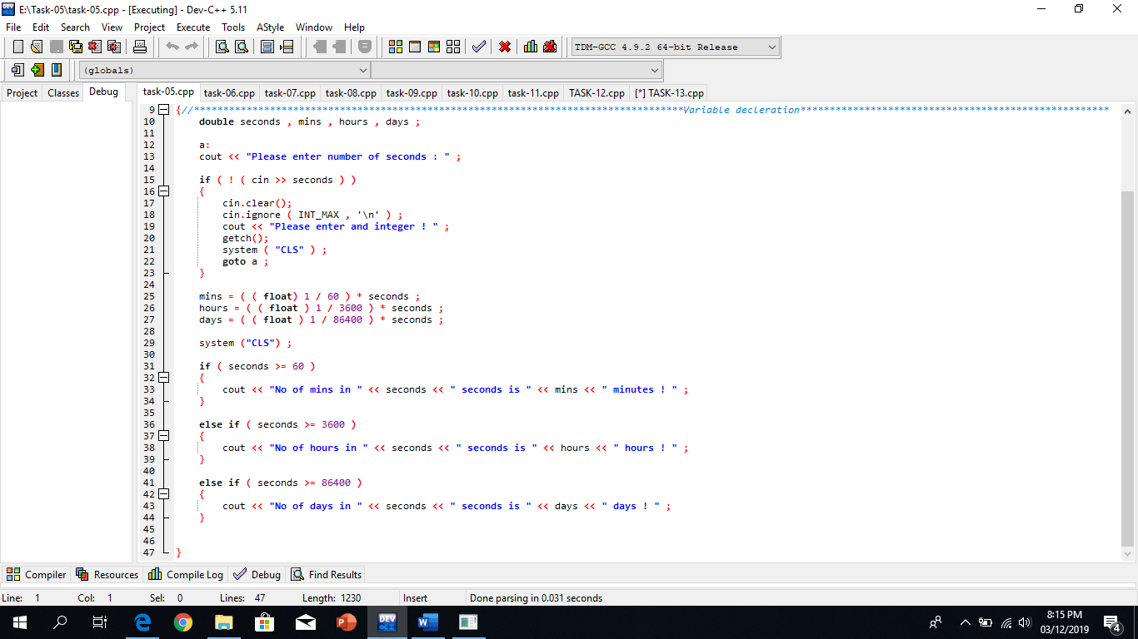

**OUTPUT:**

